**Contributor name:** NEHA KUMARI

**Book Proposed:** MANAGERIAL STATISTICS

**Total Chapters:** 23

**Total Examples:** 129

**Codable Examples:** 95

**Chapter 2: GRAPHICAL AND TABULAR DESCRIPTIVE TECHNIQUES**

Example 2.1 – Codable

Example 2.2 – Codable

Example 2.3 – Codable

Example 2.4 – Codable

Example 2.5 – Codable

Example 2.6 – Codable

Example 2.7 – Codable

Example 2.8 – Non-Codable (Reason: Incomplete Data)

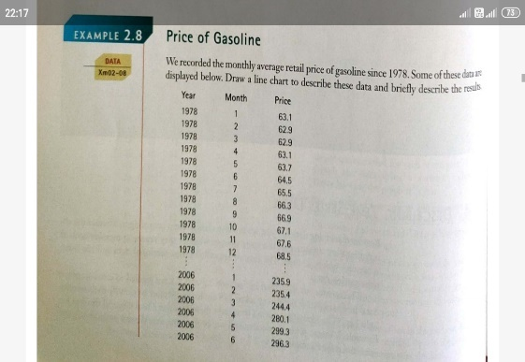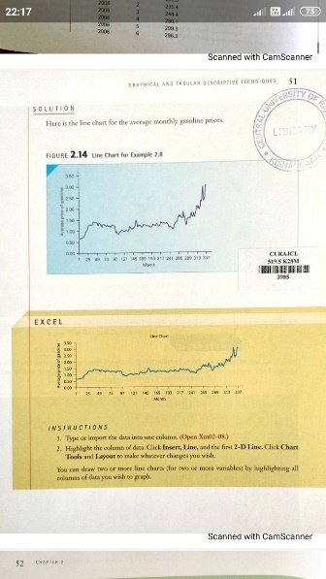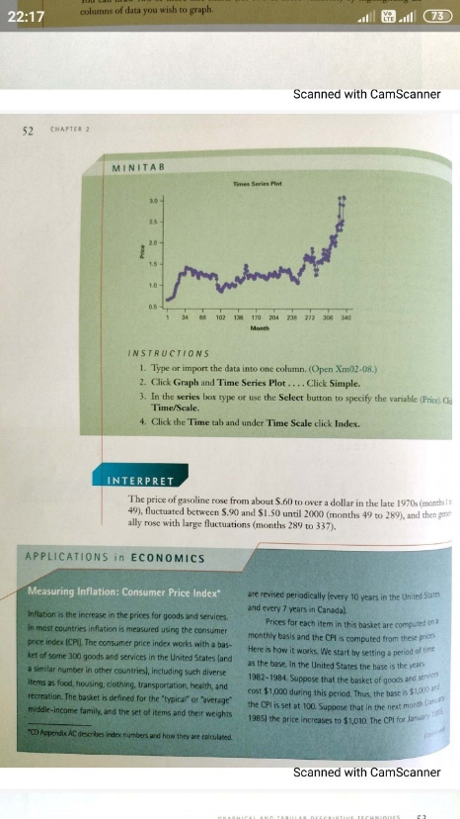

Example 2.9 – Non-Codable (Reason: Incomplete Data)

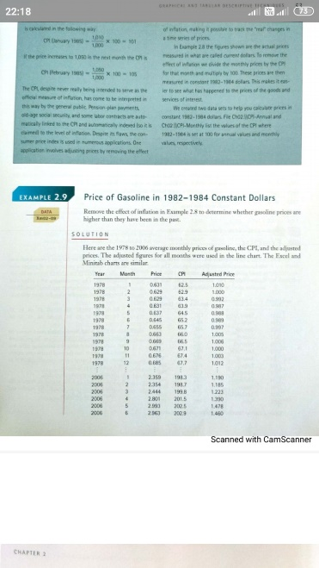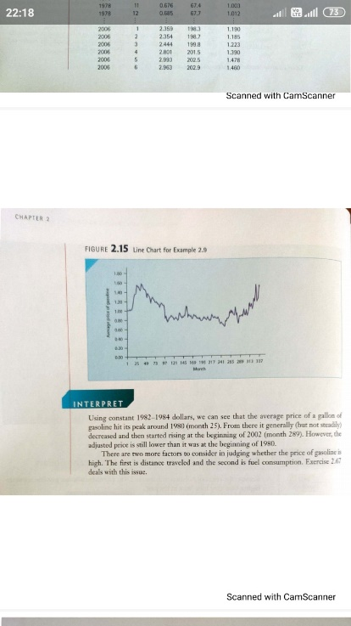

Example 2.10 – Non-Codable (Reason: Incomplete Data)

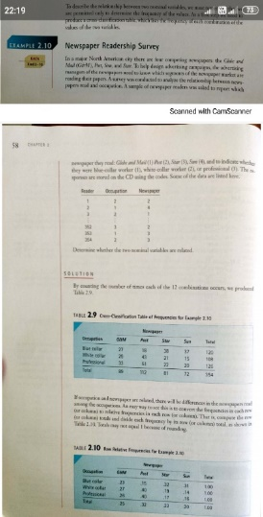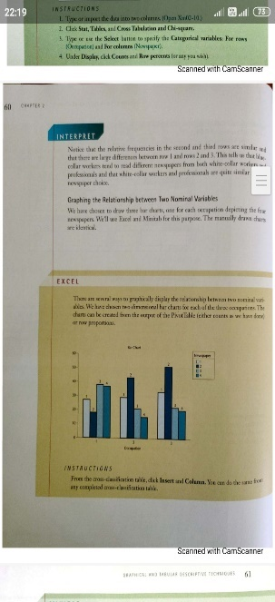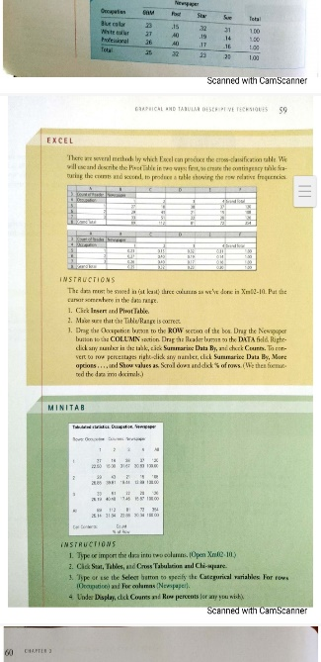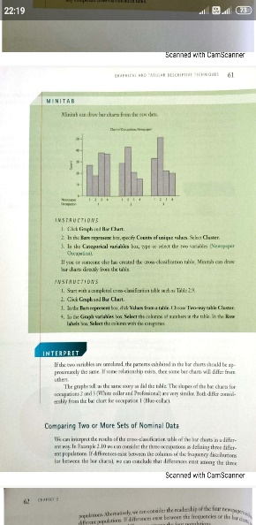

Example 2.11 – Codable

Example 2.12 – Codable

**Chapter 4: NUMERICAL DESCRIPTIVE TECHNIQUES**

Example 4.1 – Codable

Example 4.2 – Codable

Example 4.3 – Codable

Example 4.4 – Codable

Example 4.5 – Codable

Example 4.6 – Codable

Example 4.7 – Codable

Example 4.8 – Non-Codable (Reason: Data is not available)

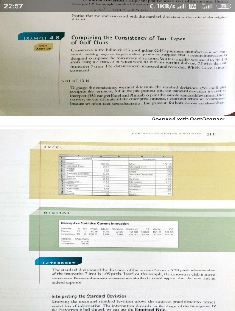

Example 4.9 – Codable

Example 4.10 – Codable

Example 4.11 – Codable

Example 4.12 – Codable

Example 4.13 – Codable

Example 4.14 – Codable

Example 4.15 – Non-Codable (Reason: Data is not available)

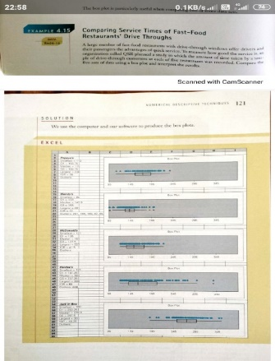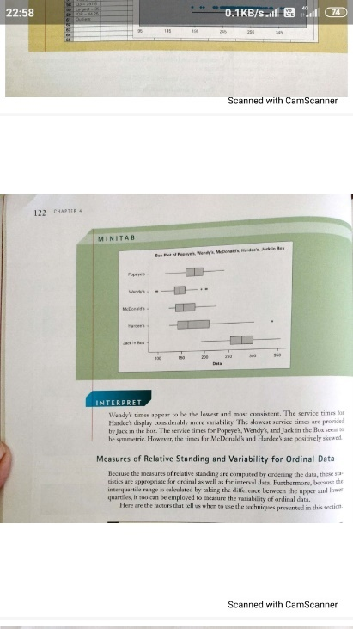

Example 4.16 – Codable

Example 4.17 – Codable

Example 4.18 – Codable

Example 4.19 – Non-Codable (Reason: Incomplete Data)

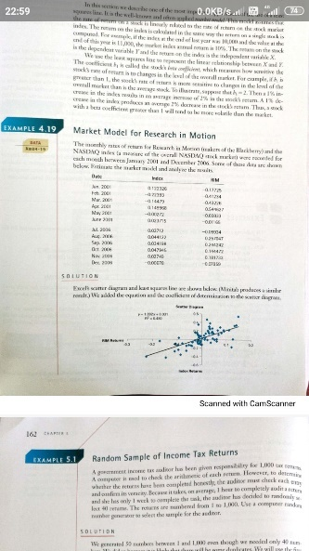

**Chapter 5: DATA COLLECTION AND SAMPLING**

Example 5.1 – Non-Codable (Reason: It is a set of random data so I can’t get the same set)

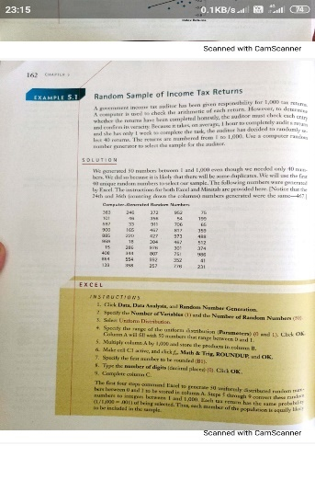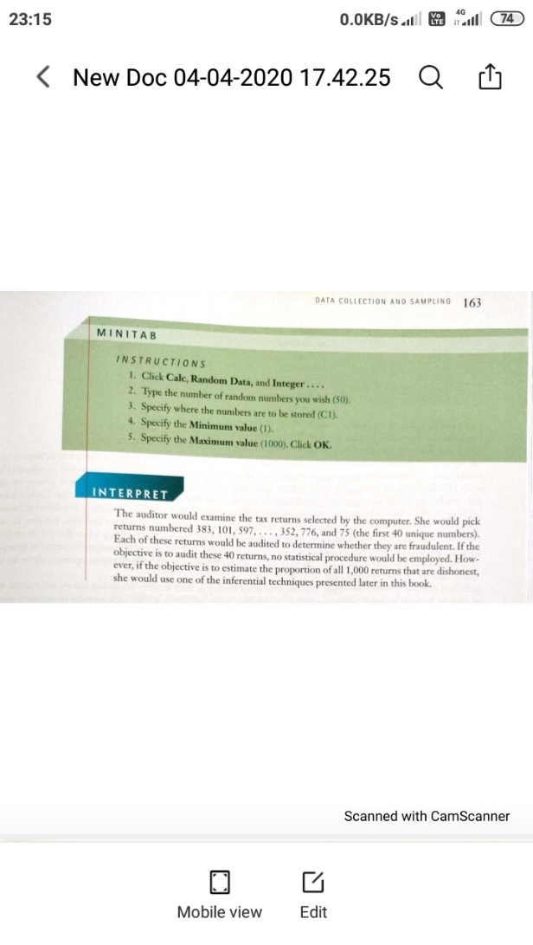

**Chapter 6: PROBABILITY**

Example 6.1 – Codable

Example 6.2 – Codable

Example 6.3 – Codable

Example 6.4 – Codable

Example 6.5 – Codable

Example 6.6 – Codable

Example 6.7 – Codable

Example 6.8 – Codable

Example 6.9 – Codable

Example 6.10 – Non-Codable (Reason: Complete solution is not available)

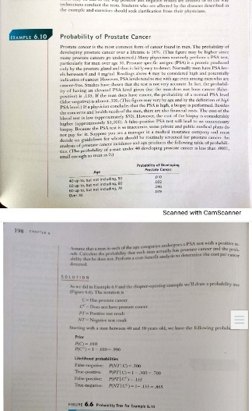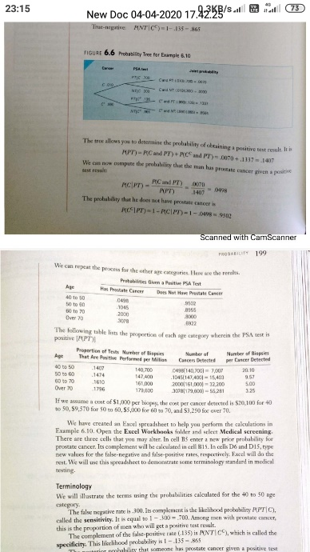

**Chapter 7: RANDOM VARIABLE AND DISCRETE PROBABILITY DISTRIBUTIONS**

Example 7.1 – Codable

Example 7.2 – Codable

Example 7.3 – Codable

Example 7.4 – Codable

Example 7.5 – Codable

Example 7.6 – Codable

Example 7.7 – Codable

Example 7.8 – Codable

Example 7.9 – Codable

Example 7.10 – Codable

Example 7.11 – Codable

Example 7.12 – Codable

Example 7.13 – Codable

**Chapter 8: CONTINUOUS PROBABILITY DISTRIBUTIONS**

Example 8.1 – Codable

Example 8.2 – Codable

Example 8.3 – Codable

Example 8.4 – Non-Codable (Reason: Theoretical)

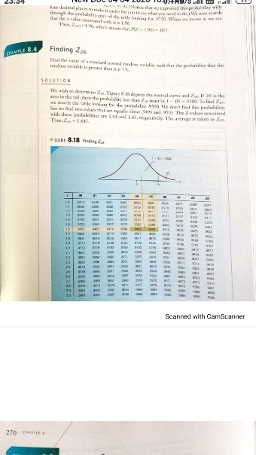

Example 8.5 – Non-Codable (Reason: Theoretical)

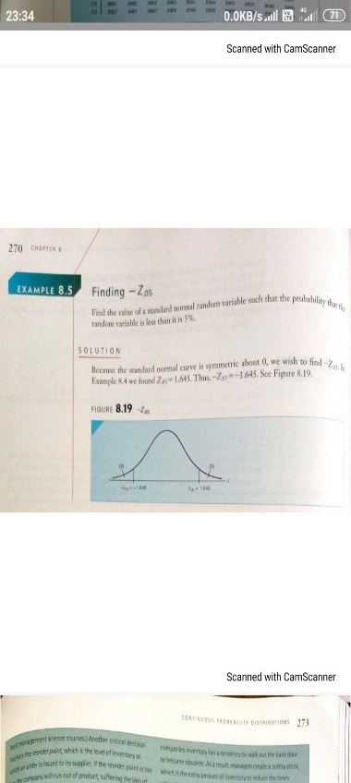

Example 8.6 – Codable

Example 8.7 – Codable

Example 8.8 – Codable

**Chapter 9: SAMPLING DISTRIBUTIONS**

Example 9.1 – Codable

Example 9.2 – Codable

Example 9.3 – Codable

**Chapter 10: INTRODUCTION TO ESTIMATION**

Example 10.1 – Codable

**Chapter 11: INTRODUCTION TO HYPOTHESIS TESTING**

Example 11. 1 –Non-Codable (Reason: Data is not available)

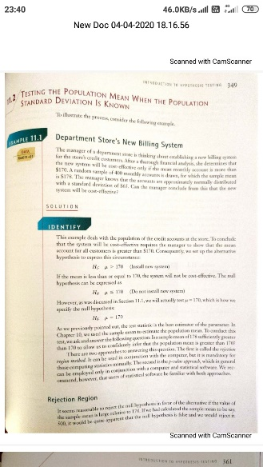

Example 11.2 – Non-Codable (Reason: Data is not available)

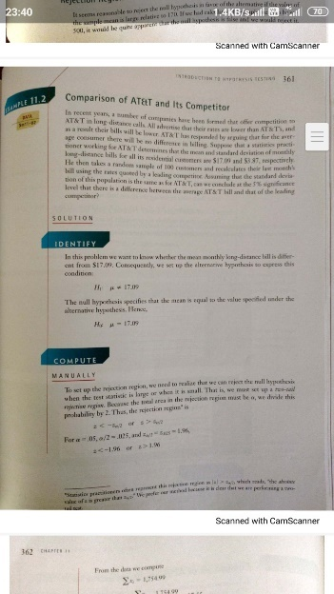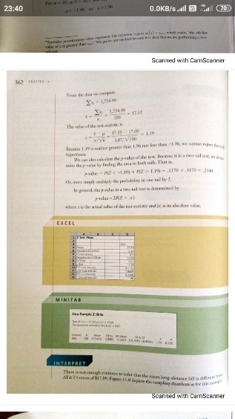

**Chapter 12: INFERENCE ABOUT A POPULATION**

Example 12.1 – Codable

Example 12.2 – Codable

Example 12.3 – Codable

Example 12.4 – Codable

Example 12.5 – Codable

Example 12.6 – Non-Codable (Reason: Data is not available)

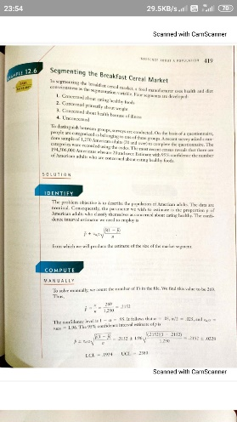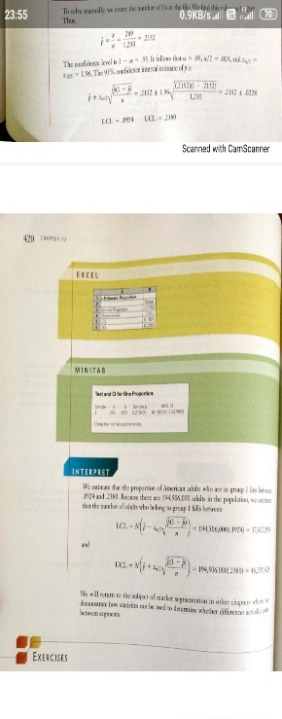

Example 12.7 – Codable

Example 12.8 – Codable

Example 12.9 – Codable

**Chapter 13: INFERENCE ABOUT COMPARING TWO POPULATIONS**

Example 13.1 – Codable

Example 13.2 – Codable

Example 13.3 – Codable

Example 13.4 – Codable

Example 13.5 – Codable

Example 13.6 – Codable

Example 13.7 – Non-Codable (Reason: Data is not available)

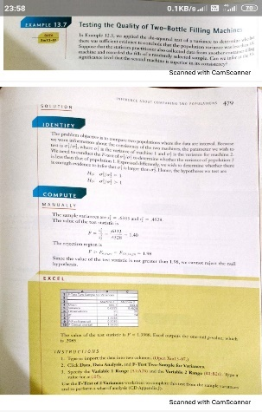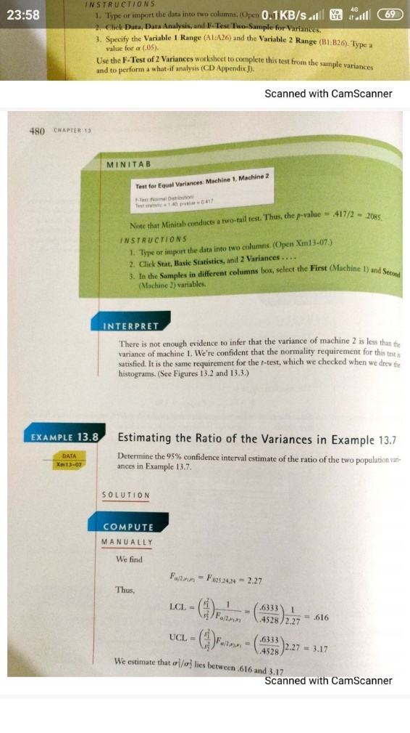

Example 13.8 – Non-Codable (Reason: Data is not available)

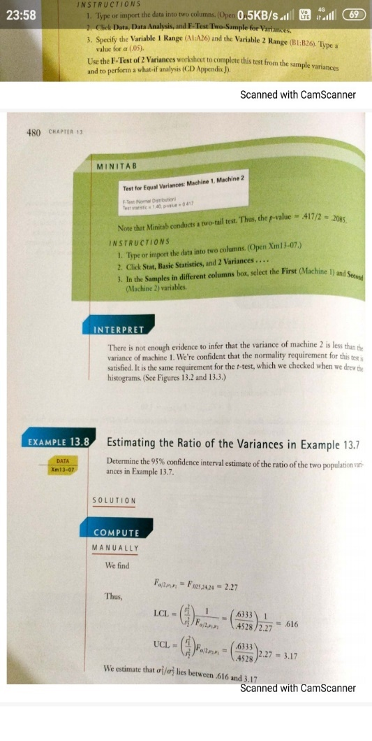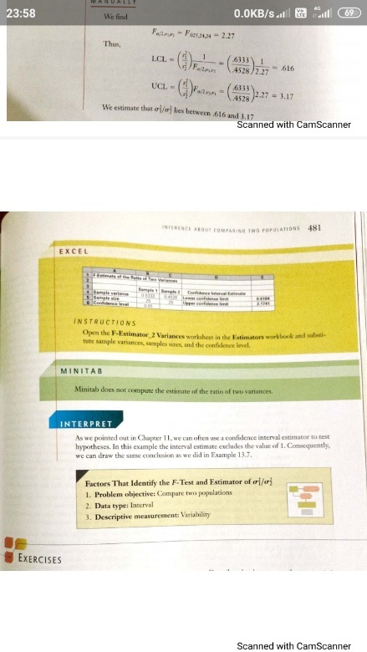

Example 13.9 – Non-Codable (Reason: Data is not available)

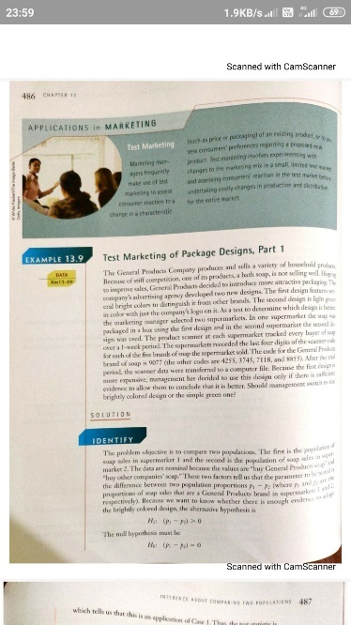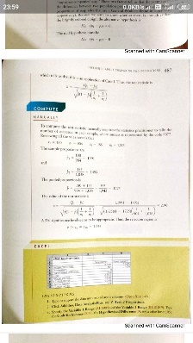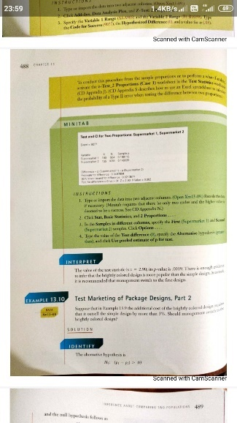

Example 13.10 – Non-Codable (Reason: Data is not available)

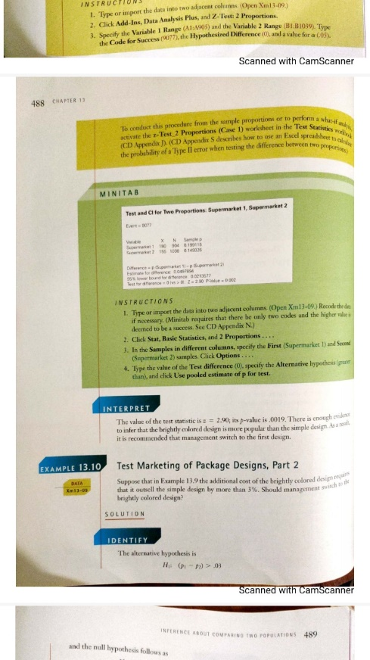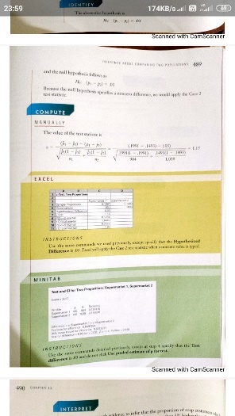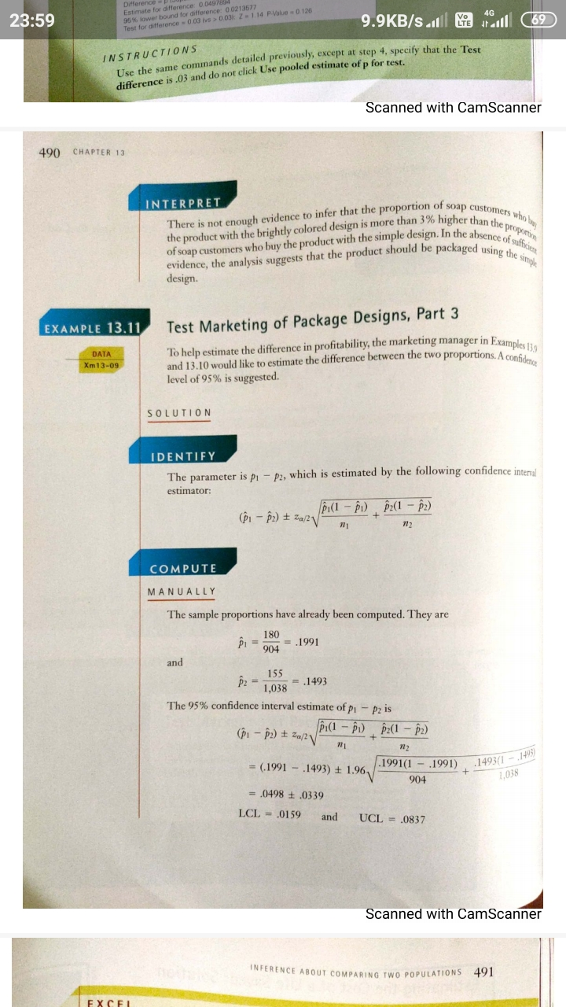

Example 13.11 – Non-Codable (Reason: Data is not available)

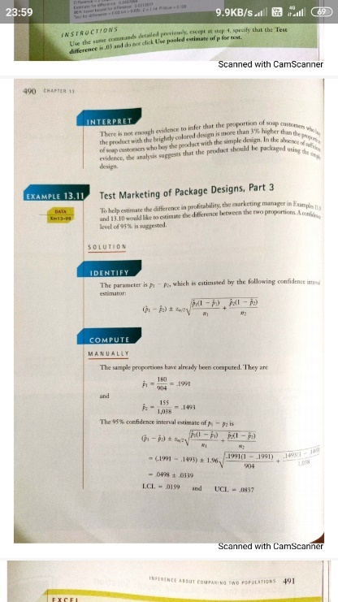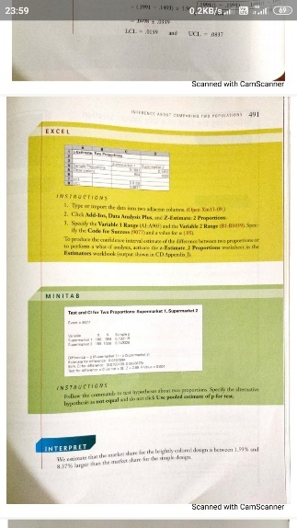

**Chapter 14: ANALYSIS OF VARIANCE**

Example 14.1 – Non-Codable (Reason: Incomplete Data)

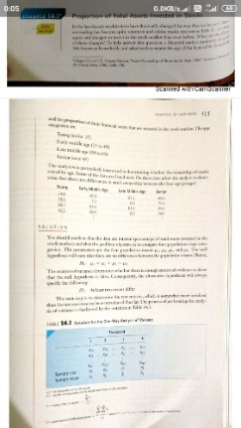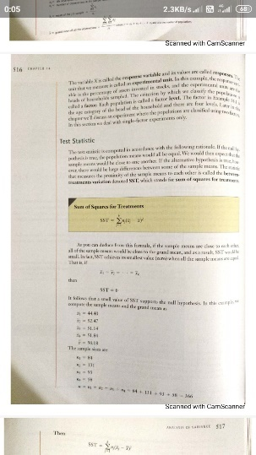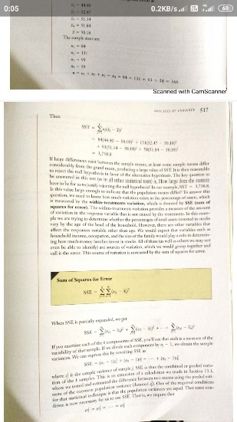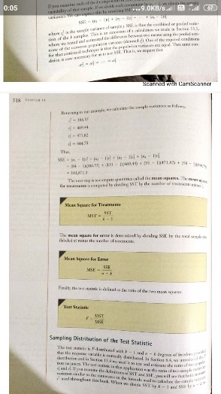

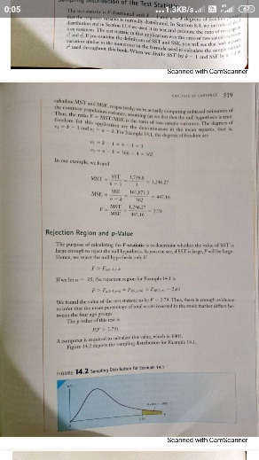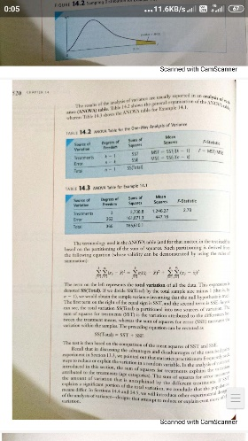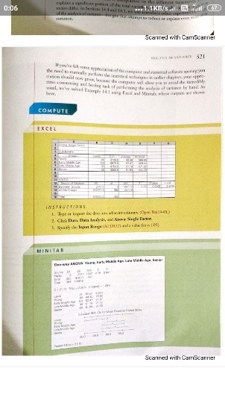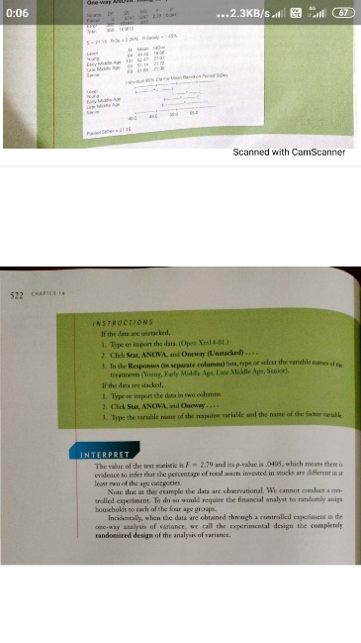

Example 14.2 – Codable

Example 14.3 – Codable

Example 14.4 – Codable

**Chapter 15: CHI-SQUARED TESTS**

Example 15.1 – Codable

Example 15.2 – Codable

**Chapter 16: SIMPLE LINEAR REGRESSION AND CORRELATION**

Example 16.1 – Codable

Example 16.2 – Non-Codable (Reason: Incomplete Data)

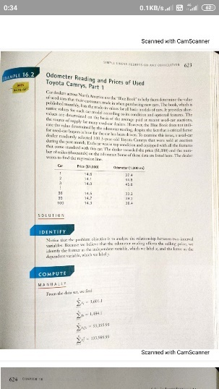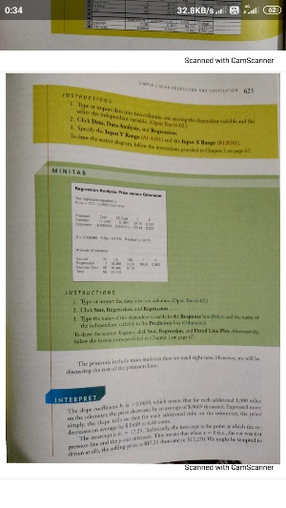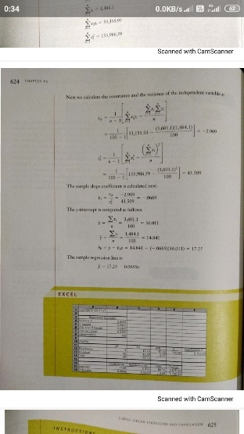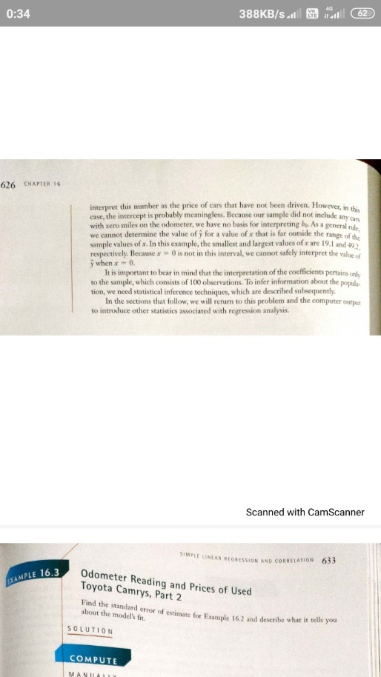

Example 16.3 – Non-Codable (Reason: Data is not available)

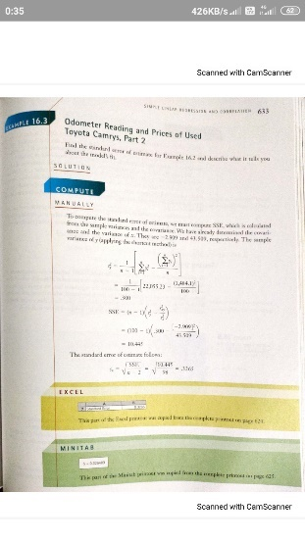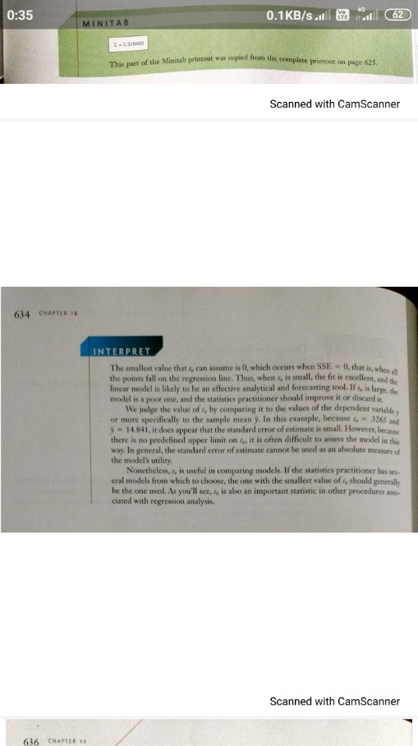

Example 16.4 – Non-Codable (Reason: Data is not available)

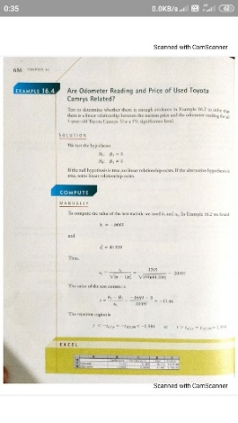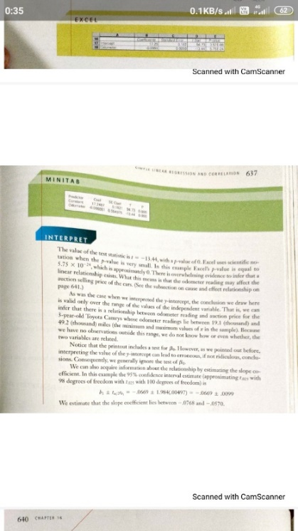

Example 16.5 – Non-Codable (Reason: Data is not available)

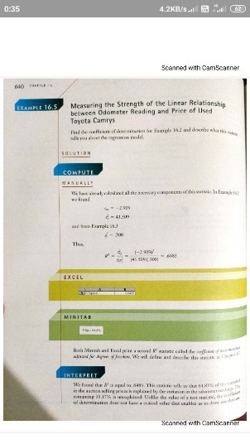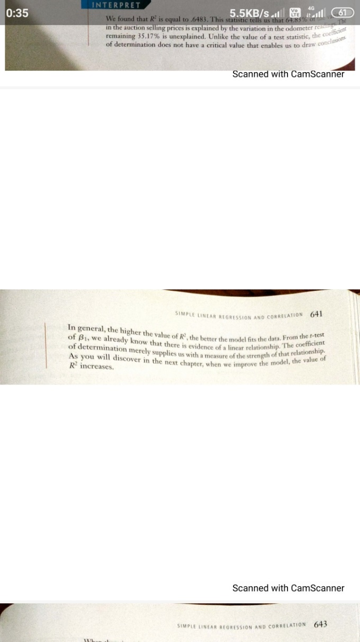

Example 16.6 – Non-Codable (Reason: Data is not available)

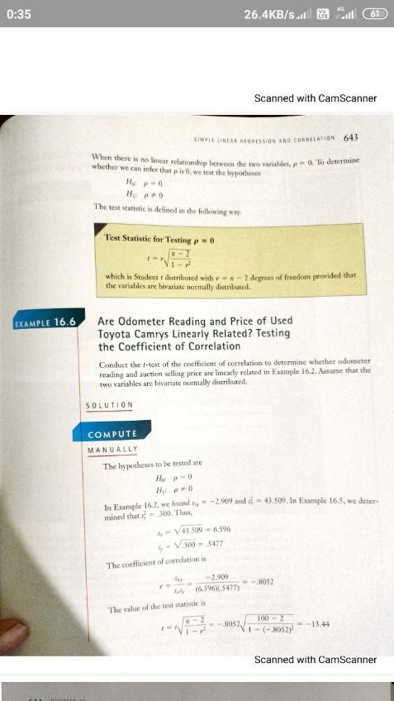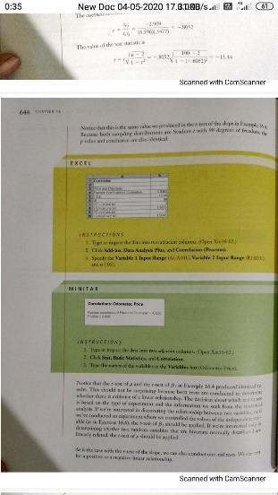

Example 16.7 – Non-Codable (Reason: Data is not available)

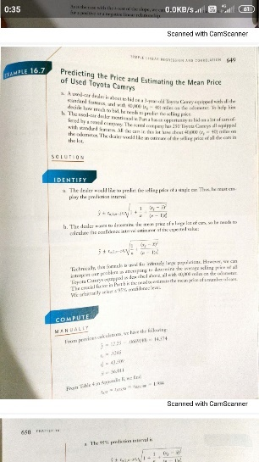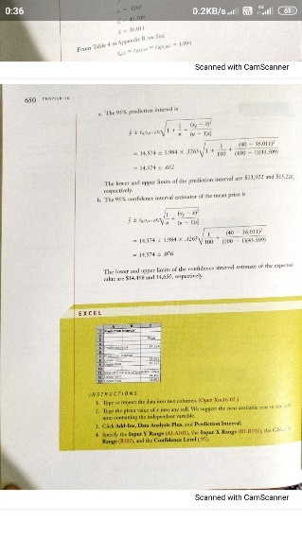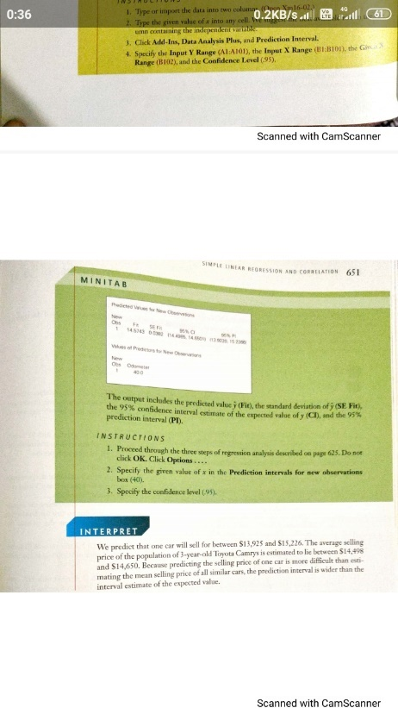

**Chapter 17: MULTIPLE REGRESSION**

Example 17.1 – Non-Codable (Reason: Data is not available)

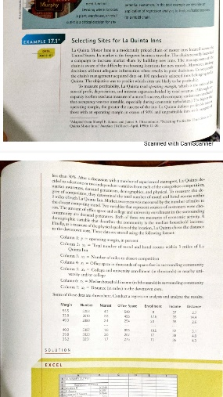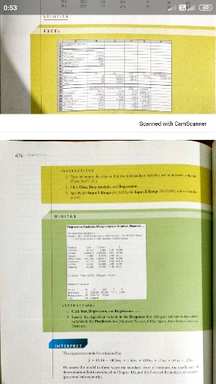

Example 17.2 – Non-Codable (Reason: Data is not available)

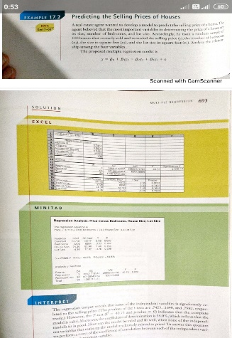

Example 17.3 – Non-Codable (Reason: Data is not available)

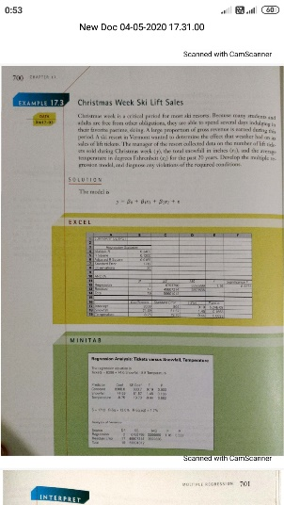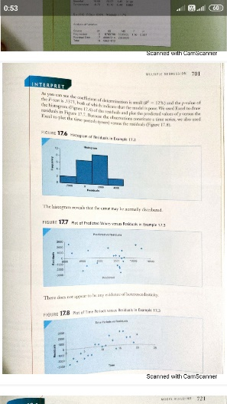

**Chapter 18: MODEL BUILDING**

Example 18.1 – Non-Codable (Reason: Theoretical)

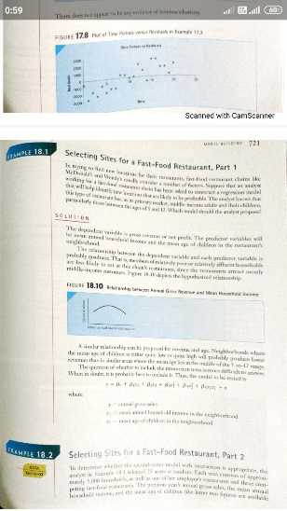

Example 18.2 – Non-Codable (Reason: Incomplete Data)

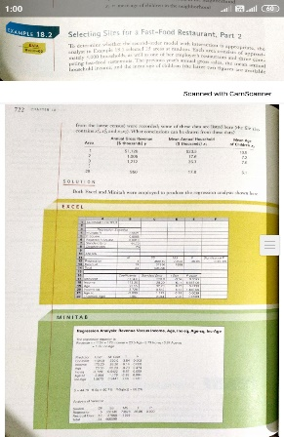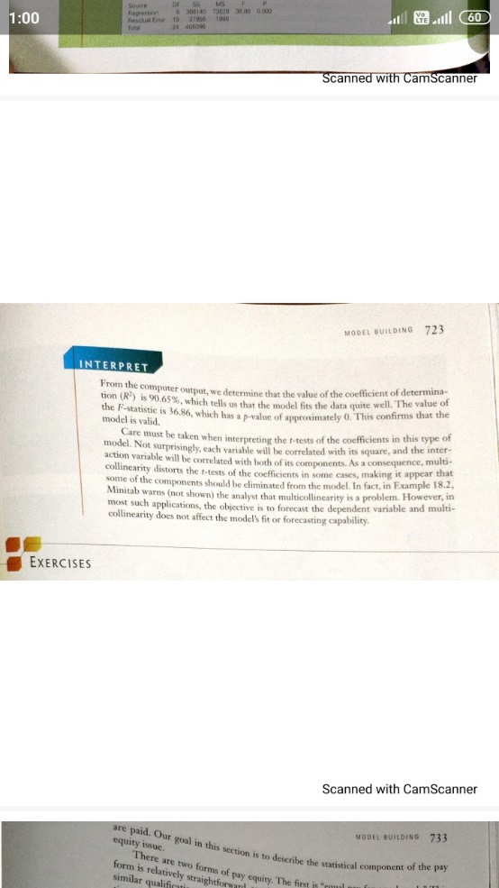

Example 18.3 – Non-Codable (Reason: Data is not available)

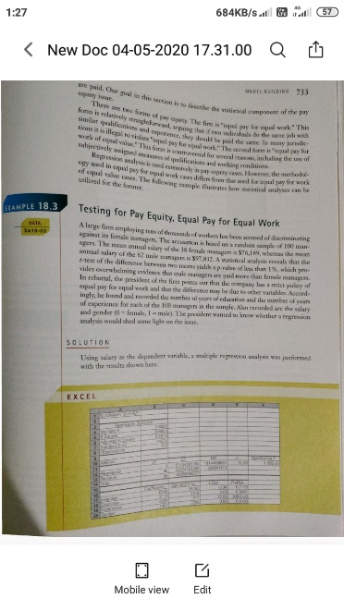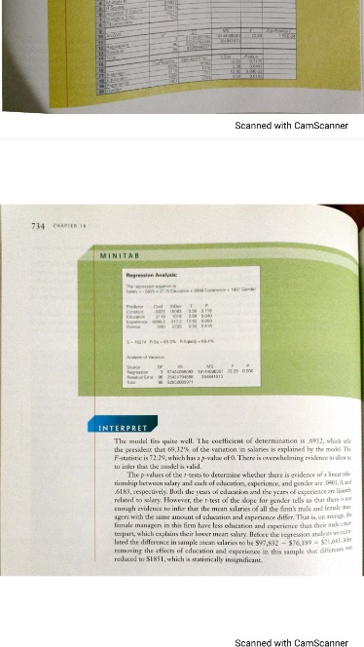

Example 18.4 – Non-Codable (Reason: can’t able to code)

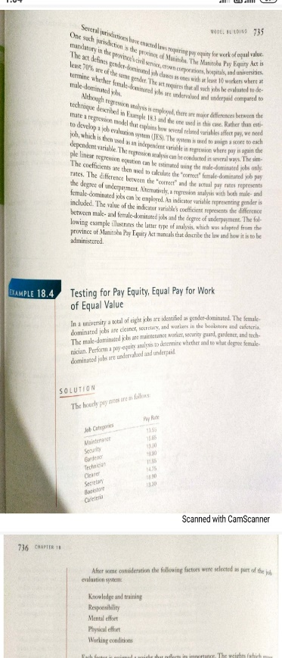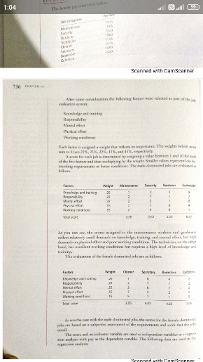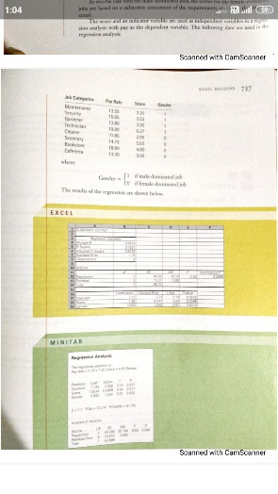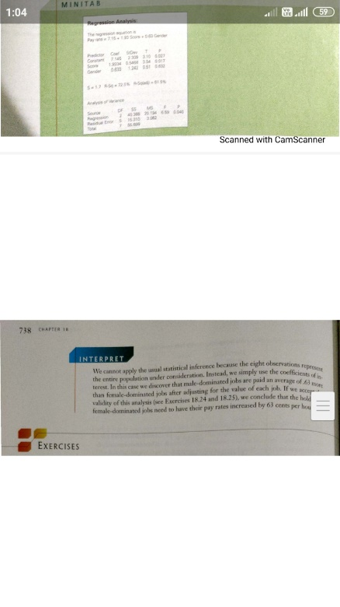

Example 18.5 – Codable

Example 18.6 – Codable

**Chapter 19: NONPARAMETRIC STATISTICS**

Example 19.1 – Codable

Example 19.2 – Codable

Example 19.3 – Codable

Example 19.4 – Codable

Example 19.5 – Codable

Example 19.6 – Codable

Example 19.7 – Codable

**Chapter 20: TIME SERIES ANALYSIS AND FORECASTING**

Example 20.1 – Codable

Example 20.2 – Codable

Example 20.3 – Codable

Example 20.4 – Codable

Example 20.5 – Codable

Example 20.6 – Codable

**Chapter 21: STATISTICAL PROCESS CONTROL**

Example 21.1 – Codable

Example 21.2 – Codable

Example 21.3 – Codable

**Chapter 22: DECISION ANALYSIS**

Example 22.1 – Non-Codable (Reason: can’t able to code)

